2.8 Chorazin
(Chorazin; Khirbet Karazeh)

Summary of the description of the Property and its history and development
New Testament reference
The scolding of Chorazin's inhabitants: Matthew 11:20-24; Luke 10:12-16
Significance
In the Jewish village of Chorazin, Jesus preached and performed miracles, but the villagers refused to follow him and were scolded in the well known chastisement passages “Woe to you, Chorazin! Woe to you, Bethsaida!" (Matthew 11:21). This archaeological site is a rare example of a typical Talmudic late Roman – Byzantine village, set in a pristine natural and agricultural landscape, which has not changed much in the last 4,000 years. The site of Chorazin and its environment, illustrates the spatial frame of the activity of Jesus in the region.
Description of Property
Today Chorazin is an archaeological site in a National Park. North of the Chorazin-Almagor road is the Early Roman period quarter (unfenced). South of the road - excavated and partly restored central quarter of the village from the late-Roman – Byzantine periods. Main feature include: partly restored monumental basalt-built synagogue with richly carved architectural elements. North and east of Chorazin: Dolmen megalithic tombs
History and Development
Village founded in the Iron Age II. The Early Roman period village located in the northern part of the present site, in the late-Roman period the village expanded southwards. The Byzantine period – a climax in the village history when the synagogue and surrounding private quarters functioned. Synagogue investigated since the 19th century; wide scale excavations of Synagogue and central quarter in the 1960's and 1980's. Soundings in the early-Roman period northern quarter. 1980's-90's: Restoration of synagogue and private quarters, opened to the public as a national park

Detailed description of the Property and its history and development

Name and Identification
Ancient Chorazin, whose inhabitants were upbraided by Jesus, is undoubtedly identified with the site of Khirbet Karazeh (the Arabic name of the ruin), 4 kilometers north of Capernaum; Chorazin is the Hebrew/Aramaic rendering of the name, based on a lone Talmudical passage mentioning the environs of Chorazin in connection with bringing the Omer wheat offering to the temple in Jerusalem (Tosephta Menahot 9:2; Babylonian Talmud Menahot 85a).

Description of Chorazin at the present time
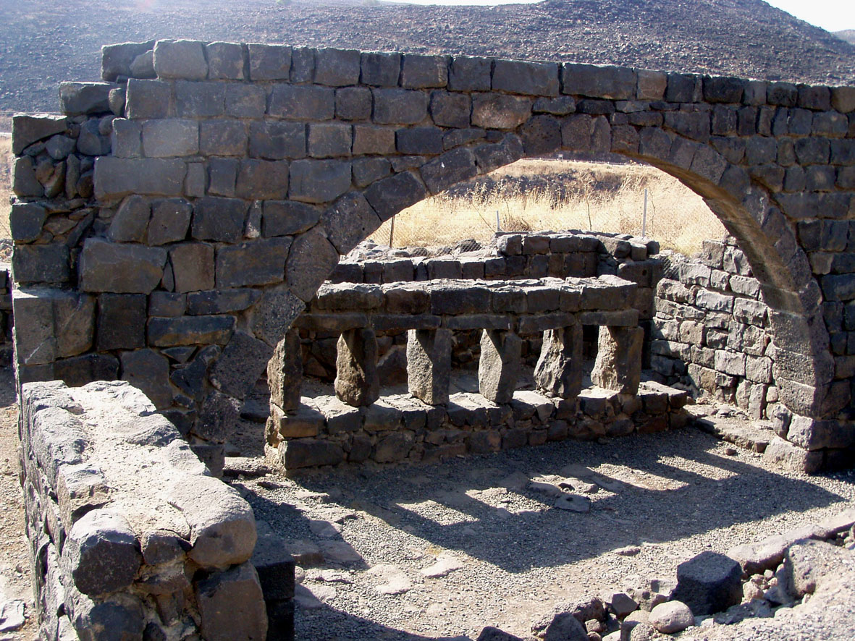
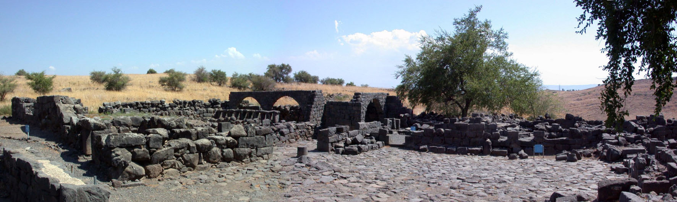
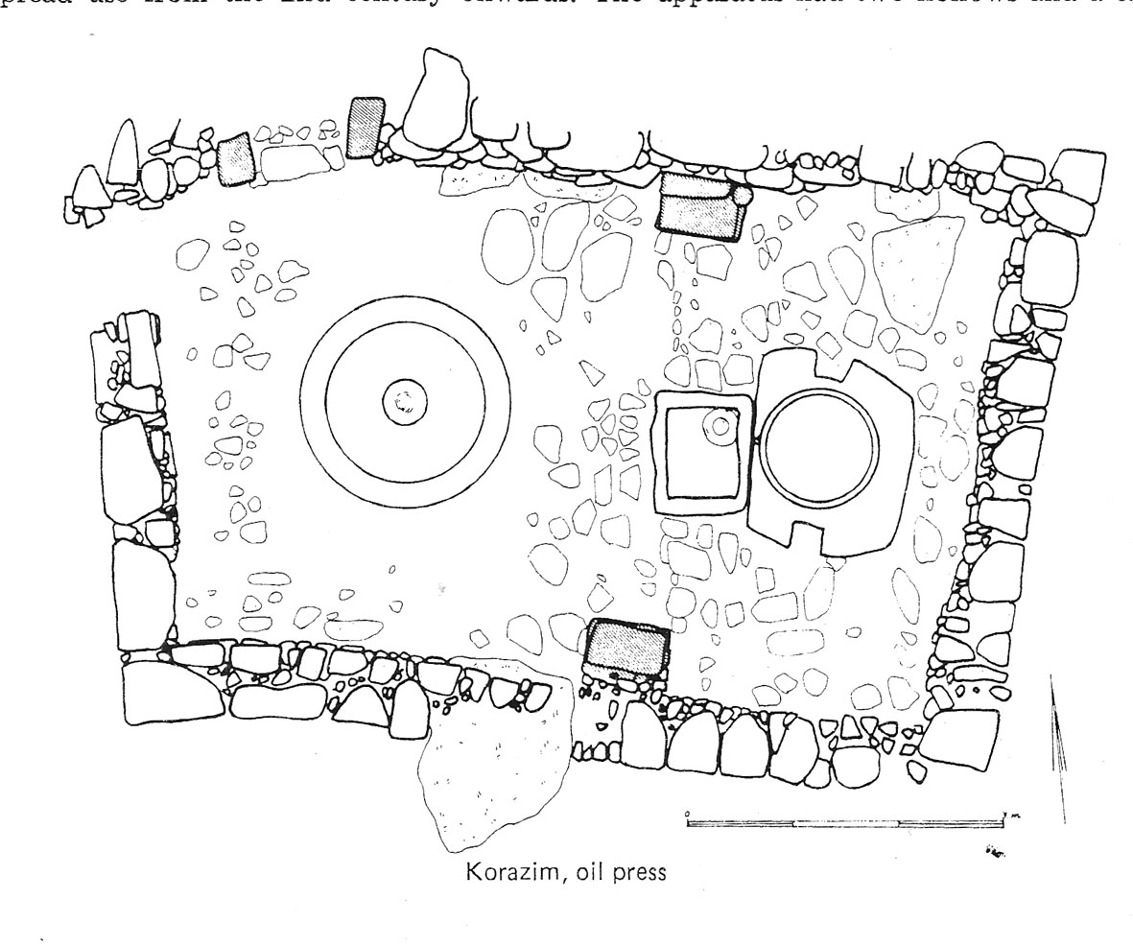
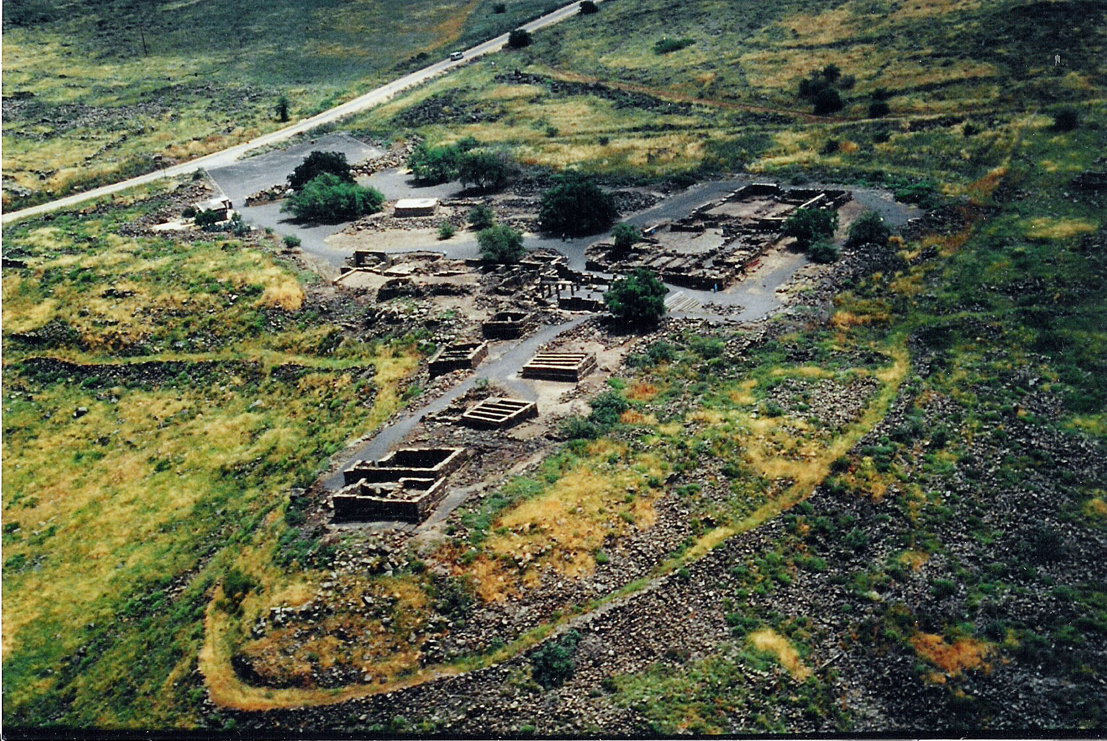
The ancient village is situated on an elongated basaltic rocky spur and its slopes, covering an area of c.a. 200-250 dunams (Fig. 96.). At the present time, the major central part of the ancient village to the south of the Chorazin – Almagor road is fenced off and functions as a National Park, open to visitors daily 0800-1600 (winter) or 0800-1700 (summer). The northern part, north of the road, is an open-air ruin separated from the road by an easily-penetrated wire fence. close to the road early and mid-Roman period structural finds were discovered in two small and limited soundings in the 1980's (see below); the stone crushing and pressing basins of the olive press dated to the 1st-2nd centuries was uncovered in those excavations (Yeivin 1984: 70) (Fig. 97.). Additional above-surface structural remains that are visible in this quarter give good reason to believe that further investigation of this area will yield additional discoveries from this relatively early stage in the settlement history of Chorazin, including the early and mid-first century C.E., the period of Jesus.
A parking lot on the southern side of the road and small kiosk (presently not functioning) are located just outside the entrance to the Chorazin park, while just inside the entranceway is a small basalt stone-built building housing restrooms and the caretaker's ticket-office and management rooms. To the east of this building, left of the entrance is a small shaded picnic area, next to which a green-painted fenced-off Arab Sheikh-tomb called 'Sheikh Ramadan' is visible. The visit to the village's excavated remains dating mainly to the 3rd-6th centuries C.E. begins here, where the first of a series of explanatory semi-transparent placards with a short history of the Galilee has been posted (for a more detailed description of the remains, see below). From here a gravel path leads us southwards, along the route of what seems to be the main north-south street that separated the eastern and western sections of the civic center of Chorazin. The first excavated remains are visible along the street's western side (housing quarter H) (Fig. 98): these include a partly-restored structure with arched-walls and an adjacent ritual bath complex. From here the visitor may continue east, to the courtyard houses C and D, where cleaning and restoration work enables a better understanding of the original layout of these exemplar dwellings (Fig. 99). A path leading out through the southern façade of the western building C directs the visitor westwards to the main attraction of Chorazin: the grand ancient synagogue, which has been partly reconstructed. Outside the building and inside it are more placards with explanations on the synagogue's plan and architectural features, including different options for reconstructing the upper story of the building (another placard, that will cater to Christian visitors, is planned to be posted on a high spot to the south-west of the synagogue in the near future). Certainly the most striking aspect of the synagogue are the finely carved decorated basalt reliefs, renown for their finesse; an especially appealing relic is a well-made gypsum duplicate of the original famous stone 'Seat of Moses' discovered here in the 1920's, that has been posted here in its assumed original position, on a raised canopied Bema between the central and eastern entrances leaning on the southern inner wall. From the synagogue the gravel path leads the visitor to the western spur, where several structures were excavated and one fully restored to its original Medieval-period height. The westernmost structure at the head of the steep western slope, from where a good view of the Chorazin Brook and surrounding area is obtained (here also a placard provides information on the Geology of the area), houses a well-preserved in-situ olive-press, one of three that have been excavated at Chorazin. Here ends the visit within the Chorazin park; on the way back to the entrance one should look south and observe the as yet unexcavated southern lower parts of the village, waiting for their turn to be uncovered by the digger's spade.
Fig. 97. Plan of excavated 1st-2nd centuries C.E. Olive Press.
Fig. 99. Excavated and partly reconstructed Late Roman – Byzantine building H.
Fig. 98. Excavated and partly reconstructed Late Roman – Byzantine living quarter (courtyard C, building D).
Fig. 96. Aerial photo of excavated and partly reconstructed central quarter of Chorazin (view from SW)

History and Development of Chorazin
Outline of Archaeological Research and Development at Chorazin
After the discovery and identification of Chorazin in the middle of the 19th century, the town's synagogue was first identified by C. Wilson in 1869 and surveyed a number of times until the turn of that century. During the years 1906-1909 the synagogue was first excavated by Kohl and Watzinger, who proposed a drawn reconstruction of the edifice (Kohl and Watzinger 1916: 41-58). In 1926, in wake of the allocation of the site to several families from the hauran (Syria), Y. Ory, N. Makhouly and N. Avigad conducted further excavations and a cleaning of the synagogue and its narthex, including the placement and display of the original architectural elements that were uncovered on site along the inner walls of the building, a state of condition that lasted until the 1960's after the establishment of the State of Israel (1948). In 1962-1964 a survey and extensive excavations were conducted on behalf of the Israel Department of Antiquities, directed by Z. Yeivin, in the synagogue and the town environs (Fig. 100). During the years 1980-1987 these excavations were resumed and widened with the aim of opening the site to the public and displaying the remains of the Talmudical village, stressing its history and importance to both Jewish and Christian pilgrims and visitors. This endeavor was sponsored by the Dept. of Antiquities and the National Parks Authority and again directed by Z.Yeivin, supplemented by preservation and restoration activities carried out in parts of the synagogue and in parts of the living and industrial (olive-oil production) quarters to the east, west and north of the synagogue. In the 1990's the National Park Authority continued restoration work and upgraded the site for visitors by installing tourist facilities (mainly a parking lot, walking paths, bathroom and running water utilities, a small picnic area and explanatory signs).
The History and Archaeology of Chorazin
(Yeivin 1982; 1984; 1993; 2000) Although Chorazin is not recorded in historical sources before the 1st century C.E., pottery from the Iron Age II (9th-8th centuries B.C.E.) collected in a survey of the site pushes back the date for its founding at least to the era of the northern kingdom of Israel in old Testament times (Stepansky 2000: 9*). Chorazin is first mentioned in the 1st century C.E. Gospels of Matthew and Luke and in a 2nd century C.E. Talmudic passage (above), however in the early 4th century C.E. Eusebius describes the village as lying in ruins: "A village of Galilee. Christ lamented over it, according to the Gospel. Now it is deserted, two milestones away from Kapharnaoum" (Onomasticon 23, 174). Another source on Chorazin is the retroactive 12th century account of Peter the Deacon, based on and reflecting earlier sources, describing seemingly unsuccessful attempts by the Jewish villagers of Chorazin to build a synagogue: "Not far from there is the synagogue which the saviour cursed. While the Jews were building it, he went by and asked them this question, 'What are you doing?', 'Nothing', they said, and he replied, 'if it is nothing you are doing, then what you are doing will forever be nothing!' And till this day it remains so. For after that, whenever the Jews decided to build, the work they did in the day used to fall down in the night, and in the morning their building was at just the height it had been at the moment when it was cursed" (Wilkinson 1981: 200-201). These accounts notwithstanding, Chorazin for most parts of the Late Roman and Byzantine periods was a thriving Jewish village, especially during the latter period when an elaborately decorated synagogue is witness to its prosperity. This conclusion, based on the archaeological evidence, emphasizes the importance of archaeological investigation when there is an absence or shortage of firm historical sources, as is the case for Byzantine Chorazin. From the 8th century C.E. and onward, there is a decline and probable abandonment of the site until the 12th-13th centuries when a small and sparse settlement was re-established which sustained for several centuries, until the final demise of the site sometime during the Ottoman period (16th-20th centuries, save for a squatter settlement in the 19th-20th centuries).
The earliest dated architectural remains in Chorazin were found in the soundings conducted by Z. Yeivin in the northern area of the site, slightly north of the present road to Almagor. These include a wall of large dressed stones with a doorway foundation and adjacent stone-pavement, on which were found several pottery vessels dated to the 1st and 2nd centuries c.e (Yeivin 1982:64), and a well preserved oil press with crushing and pressing basins dated to those centuries (Yeivin 1984: 70). These finds lead the excavator to believe that Chorazin from the time of Jesus was located primarily in this northern area of the site, for only here were found substantial Early-Roman period remains (Yeivin 2000:31). Several Hellenistic and early-Roman period coins (Ariel 2000:35) and scattered early-Roman period sherds (Yeivin 1973:156; Yeivin and May 2000) found in several of the synagogue loci also indicate an occupational phase in the time of Jesus, although as yet no certain structural remains dating to earlier than the 3rd century C.E. have been found south of the modern road to Almagor .
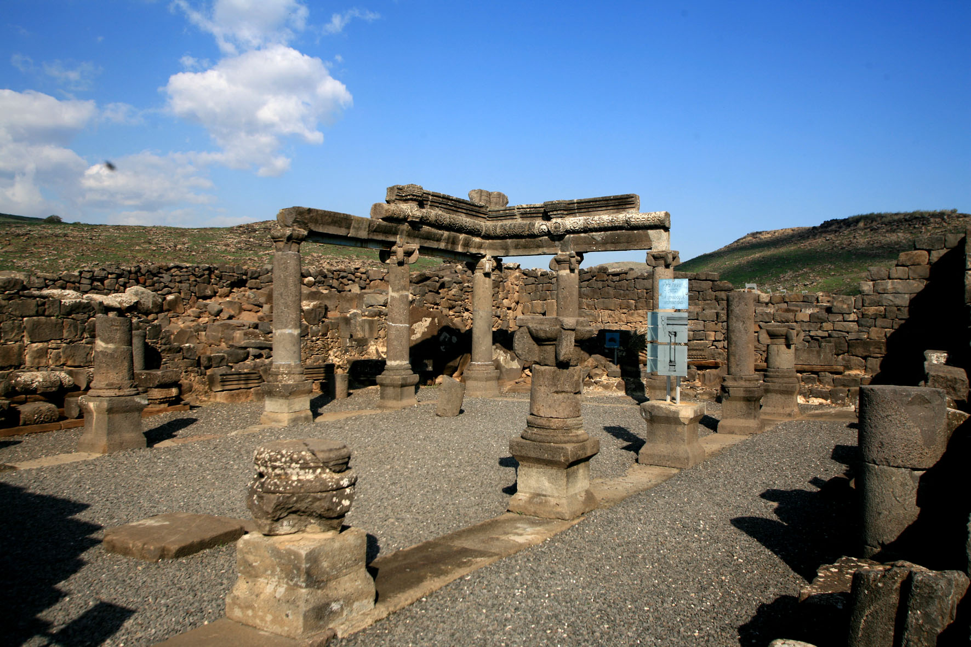
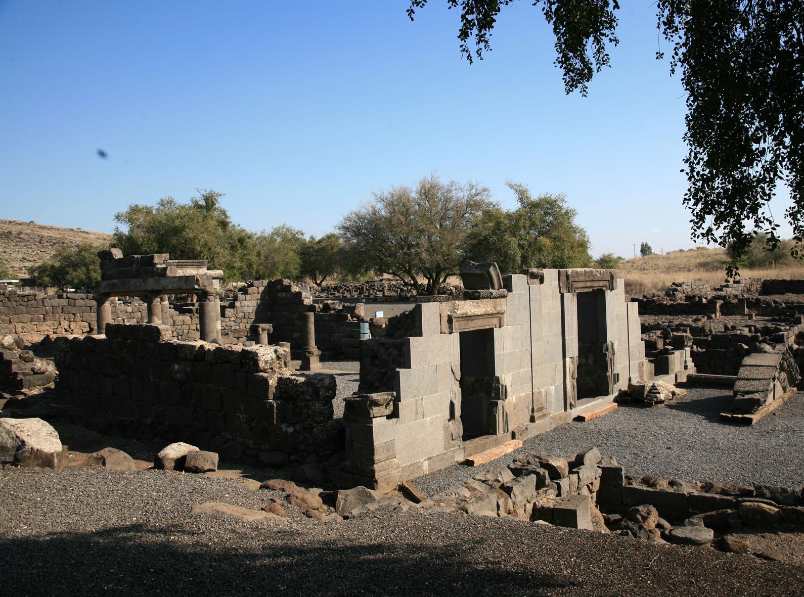
During the 3rd and especially the 4th-6th centuries Chorazin spread southwards, along the moderately-sloped rocky basaltic spur where today the civic-center of the village may be seen, and along it's western and southern inclines. In these central and southern parts of the site excavations have revealed the main components of a typical ancient Talmudic Jewish village: the town synagogue, a ritual bath, typical domestic quarters and additional oil presses.
Fig. 101. Synagogue interior, looking north-west
Fig. 102. Synagogue façade, looking north-east
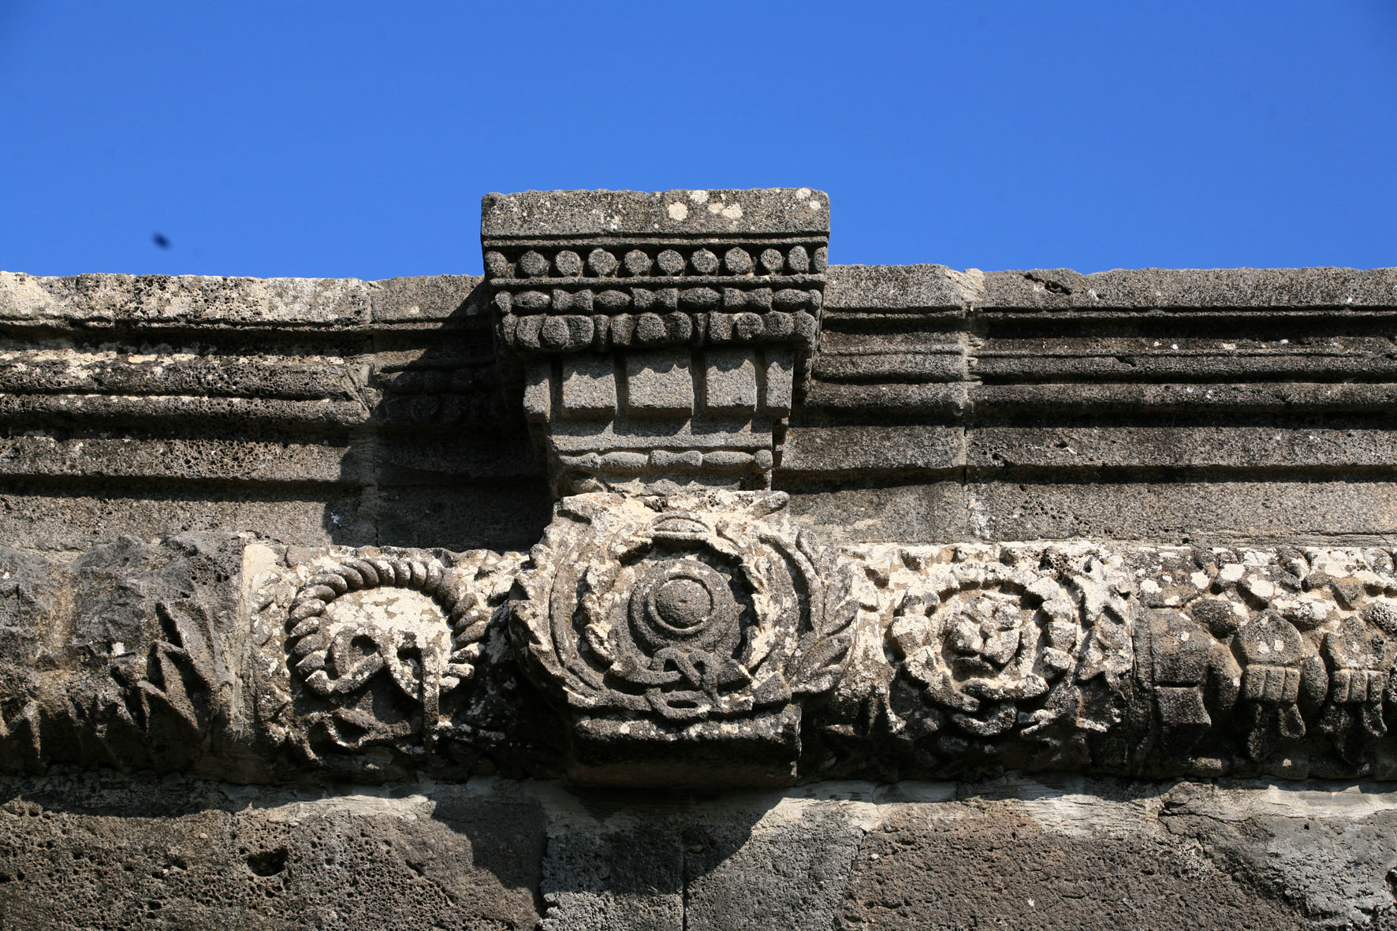
The synagogue of Chorazin (Yeivin 2000), which has been investigated since the middle of the 19th century and excavated a number of times thereafter, is a classic example of the Galilean type: a monumental basalt ashlar-constructed basilica with three doorways in the Jerusalem-oriented (south) wall, a main hall divided by 12 pedastaled, stylized Ionic columns into a nave and three surrounding aisles, and benches lining the inner western, eastern and northern walls (Figs.101, 102). The building's location on a raised platform to which ascended a monumental flight of steps gave the synagogue a grand and commanding appearance. The interior and exterior of the building were richly decorated with finely carved basalt reliefs, displaying human, fauna and flora motifs (Fig. 103). Other architectural elements found scattered in the vicinity of the synagogue have been identified as parts of an aedicula (Torah Shrine) and of a Bema (raised stepped-platform upon which the Torah was read and sermons preached) that abutted the southern inner wall within the prayer hall (Yeivin 2000: fig. 14, p. 63). On the latter probably stood the famous stone-seat discovered in the 1920's, labeled the 'Seat (Cathedra) of Moses', on which is inscribed an ancient Aramaic inscription stating: 'May Yudan bar Ishmael be remembered with favor, who made this stavah [= Itstaba, platform] and the steps. May his lot be with that of the righteous'. A concise study of all the architectural fragments has led the last and main excavator of the site, Z. Yeivin, to prefer reconstructing the eleven meter high building with an upper clerestory bearing decorated conch-adorned windows (Yeivin 2000: plans 10-12, pp. 57, 59). The dates given by Yeivin for the synagogue's construction history and periods of employment are:
Fig. 103. Decorated Basalt relief in Synagogue interior
- Initiation of construction - the beginning of the fourth century C.E.
- A halt in construction shortly after (possibly compatible with Eusebius's description of the site being 'deserted')
- A renewal of construction and completion in the second half of the 4th century
- A continual use of the synagogue, with several intermittent repair-phases, until the end of the 6th century when the synagogue was abandoned.
This scheme, however, has recently been challenged by J. Magness (2007: 15*-17*) who has proposed a late 5th century date for the construction of the synagogue, based on the numismatic and ceramic evidence found in the few sealed loci excavated within the synagogue. In her opinion, this better explains Eusebius's description of the site being 'deserted' in the 4th century. A late 5th century date may also explain the 12th century retroactive account of Peter the Deacon, based on earlier sources, relating to initial (mid 5th century?) unsuccessful attempts by the Jewish villagers of Chorazin in building their synagogue (evidence for which was found in the excavations of the building), which was interpreted as the 'fulfillment' of the curse that Jesus laid on the site as related in the Gospels. In any case, the excavated synagogue of Chorazin was, in fact, completed; it surely played a central role in the village scene of Chorazin at least during a good part of the Byzantine period, 400-500 years after the age of Jesus.
Excavations in the domestic units to the east (C, D, F, G) and north (E, H) of the synagogue (Yeivin 2000: plan 2, p. 5) have revealed well-planned housing units with central courtyards (one of which is 13 X 5 m' in area) surrounded by 1-2 rows of rooms, enclosed by contiguous outer-walls and bordered by streets that connect to a main north-south thoroughfare. The structural walls were built with local basalt well-chiseled stones, the inner ones constructed with shelves for storage and passage of air (these are well-known in archaeological terminology as 'Chorazin windows'), while the roofs were built of basalt-beams covered with packed earth. In domestic unit H to the north of the synagogue a ritual bath complex was exposed, with an immersion pool and adjacent interconnected cistern (the Otzar in Talmudic terminology). A Preliminary evaluation for the dating of these domestic units, reflecting the main occupation stages of the town from the late-Roman period and on (not including the 1st-2nd centuries activity recorded in the northern area of the site, described above) has been given by their excavator Z. Yeivin (1973; 1982; 1984; 1993), who has identified 5 main building or repair phases beginning from the 3rd century C.E.:
- Late 3rd-early 4th centuries
- Late 4th-early 5th centuries (repairs)
- 7th-8th centuries (changes)
- 12th-13th centuries (additions and rebuilding)
- 19th-20th centuries (Khirbet Karazeh squatter huts)
In the western quarter, on the rocky spur west of the synagogue, excavations have revealed more well-built structures, including one or two that were relatively well-preserved in their medieval-period form (one of which has been restored fully to its original height) and another that housed a well-equipped oil-press whose remains are on display insitu; an additional oil-press was excavated south-east of the synagogue. Other substantial remains – including subterranean structural ruins, cisterns, an additional oil press and paved streets – were discerned in surveys of the site, especially in the extensive but as yet unexcavated area to the south of the synagogue, as may be seen in the 1960 aerial photo and general plan of ancient Chorazin (Yeivin 2000: fig. 4, p. 4; 1973: fig. 2, p. 145).
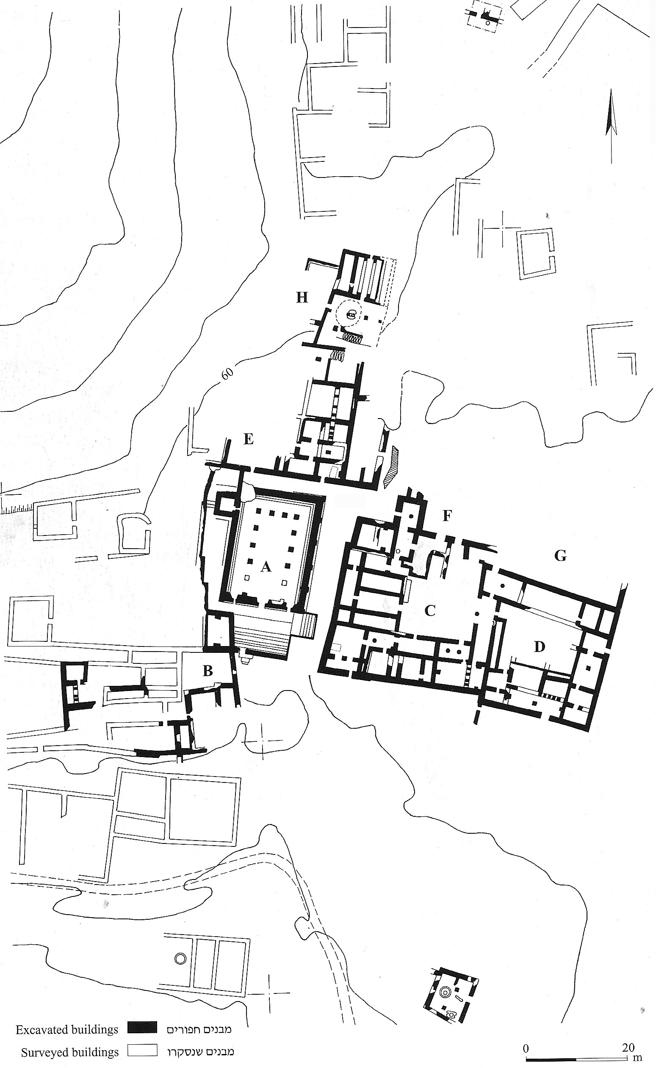
Fig. 100. Plan of Excavations: The Town Center of Chorazin from the Late Roman and Byzantine Periods, after Z. Yeivin

In 1926 The British Mandate Dept. of Antiquities Inspector J. Ori reported seeing 'roughly 200 metres W. of the synagogue… a square colonnaded building resembling the interior arrangement of the synagogue…(with) 7 columns…(and) sitting benches…' (IAA archive, British Mandate file of Karaza, Kh.). Although this building has since been left unfound and unidentified, it may actually be an early-Roman structure (a synagogue from the time of Jesus?) – waiting to be (re)discovered and investigated.

